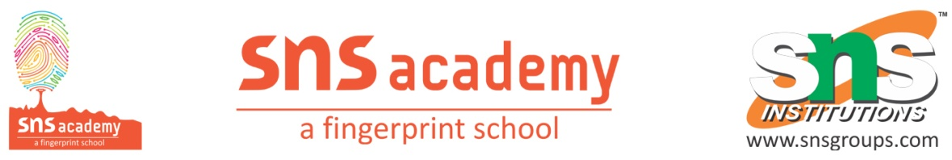
Grade – X
2. ACID,BASES AND SALTS
ANSWER THE FOLLOWING:
1. Write the chemical equation for the reaction between Lithium and Sodium Hydroxide?
2. Choose the strong acid from the following options
(a) H₂SO₄ (b) CH₃COOH (c) C₂H₅OH (d) H₂CO₃
3. An aqueous solution ‘A’ turns phenolphthalein solution pink. On addition of an aqueous solution ‘B’ to ‘A’ the pink colour disappears. The following statement is true for solution ‘A’ and ‘B’:
(a) A is strongly basic and B is a weak base.
(b) A is strongly acidic and B is a weak acid.
(c) A has pH greater than 7 and B has pH less than 7.
(d) A has pH less than 7 and B has pH greater than 7.
4. Sugandha prepares HCl gas in her school laboratory using certain chemicals. She puts both dry and wet blue litmus papers in contact with the gas.
(i) Name the reagents used by Sugandha to prepare HCl gas.
(ii) State the colour changes observed with the dry and wet blue litmus papers.
(iii) Show the formation of ions when HCl gas combines with water.
5. A cloth’strip dipped in onion juice is used for testing a liquid ‘X. The liquid ‘X changes its
odour. Which type of an indicator is onion juice? The liquid ‘X turns blue litmus red. List the observations the liquid ‘X will show on reacting with the following :
(a) Zinc granules
(b) Solid sodium carbonate
6. Write the names of the product formed when zinc reacts with NaOH. Also write the balanced chemical equation for the reaction involved. Write a test to confirm the presence of the gas evolved during this reaction.
7. Write a balanced chemical equation for the reaction between sodium carbonate and hydrochloric acid indicating the physical state of the reactants and products.
8. Which one of these has a higher concentration of H⁺ ions? 1 M HCl or 1 M CH₃COOH.
9. Why is sodium hydrogen carbonate an essential ingredient is antacids?
10. Dry ammonia has no action on litmus paper but a solution of ammonia in water turns red litmus paper blue. Why is it so?

